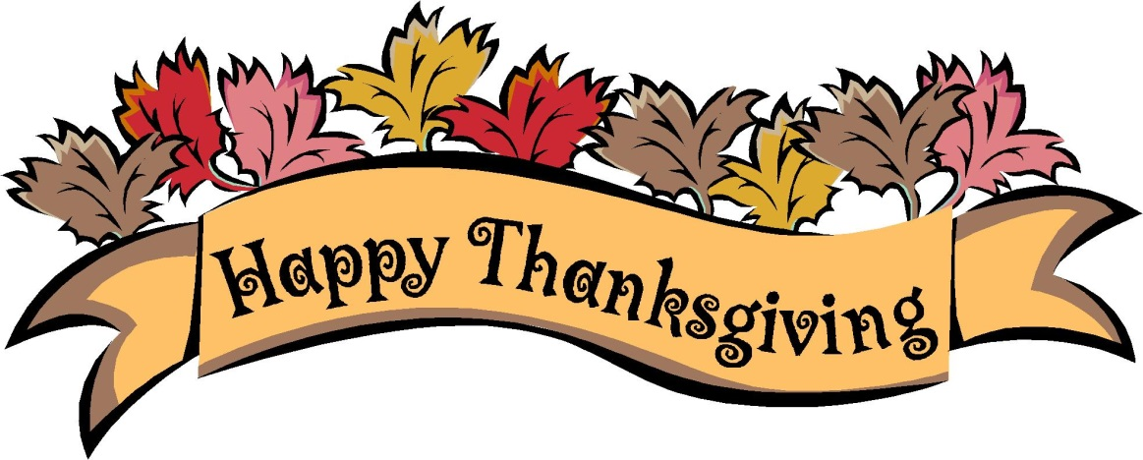**THANKSGIVING**

**STORE HOURS**

**10:00 A.M. – 4:00 P.M.**

**-THANK YOU**